**NAAN MUDHALVAN**

**Data Science**

**Project Title**

**Future Sales prediction**

**REG.NO : 712221205013**

**NAME :MADHUMITHA.K**

**DEPT : INFORMATION TECHNOLOGY**

**YEAR & SEM : III & 05**

**COLLEGE : PARK COLLEGE OF ENGINEERING AND TECHNOLOGY**

**PHASE 1**

**PROBLEM DEFINITION**

**AND**

**DESIGN THINKING.**

**Problem Definition**

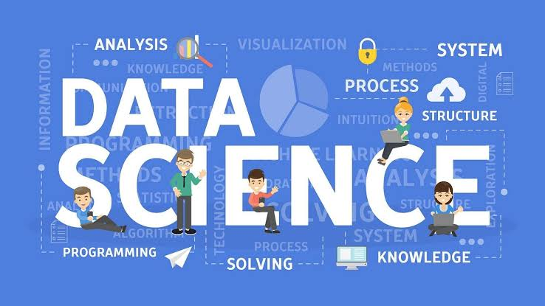**The problem is to implement data science techniques to segment customers based on their behavior, preferences, and demographic attributes. The goal is to enable businesses to personalize marketing strategies and enhance customer satisfaction. This project involves data collection, data preprocessing, feature engineering, clustering algorithms, visualization, and interpretation of results**

**Design thinking**

**Visualization**

**Statistical**

**Modelling**

**Data**

**Research**

**Statistical**

**Technology**

**Data**

**Technology**

**Data**

**Consulting**

**Scientific**

**Method**

Real-world

Application

**Visualization:**

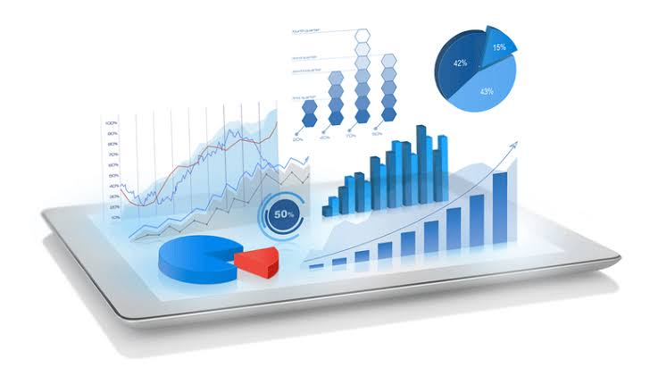 **The representation of data through use of common graphics, such as charts, plots, infographics, and even animations.**

**Statistical Modelling:**

**The use of mathematical models and statistical assumptions to generate sample data and make predictions about the real world.**

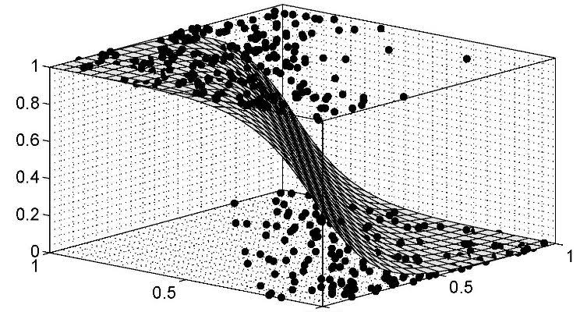**Statistical Technology:**

**Statistical methods for data science are traditionally used to organize and summarize numerical data.**

**Data Research :**

** Any information that has been collected, observed, generated or created to validate original research findings..**

**Data Technology:**

**Data technology sector includes solutions for data management, and products or services that are based on data generated by both human and machines.**



**Data Consulting:**

**Design the research plans used in data gathering and analysis.**



**Scientific Method:**

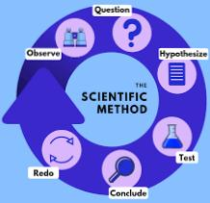

**Data set:**

**Link: https://www.kaggle.com/datasets/chakradharmattapalli/future-sales-prediction**